**Matlab – Arduino**

**USB CABLE**

<https://www.allaboutcircuits.com/projects/arduino-interface-with-matlab/>

1. **Install package in Matlab**

* **Add-ons -> Get hardware Support Packages**

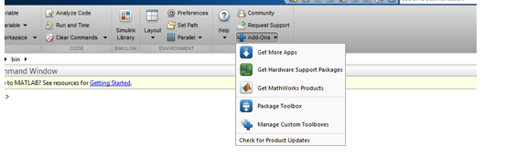

* **Install from internet and Next**
* **Select Arduino package (check all packages displayed) ->Next**
* **Next step: login in the MathWorks account**

1. **Testing**

* **Create an object for the Arduino**
* **a = arduino() or a = arduino(‘com3’, ‘uno’)**
* **if Matlab succed to communicate will Arduino, it will display the port and other information about Arduino board.**

**Example:**

**Blink a led with Matlab**

**Matlab code:**

*% create an arduino object*

*a = arduino('com3', 'uno');*

*% start the loop to blink led for 10 seconds*

*for i = 1:10*

*writeDigitalPin(a, 'D11', 1);*

*pause(0.5);*

*writeDigitalPin(a, 'D11', 0);*

*pause(0.5);*

*end*

*% end communication with arduino*

*clear a*

**Write your m-file and save it. Run your file and MATLAB will burn that file to your board.**

**Your led will start to blink.**

<https://www.mathworks.com/help/supportpkg/arduino/examples/getting-started-with-wifi-on-arduino-hardware.html>